Ideation Phase
Define the Problem Statements

Date | 26 June 2025
Team ID | LTVIP2025TMID21049
Project Name | Flight finder-Navigating your air travel options
Maximum Marks | 2 Marks

Customer Problem Statement Template:
Create a problem statement to understand your customer's point of view. The Customer Problem Statement template helps you focus on what matters to create experiences people will love.
Problem  Statement (PS) | I am  (Customer) | I’m trying to | But | Because | Which makes me feel
PS-1 | a frequent traveler | book flights quickly | the site is slow and confusing | there are too many steps and no | frustrated and impatient
A well-articulated customer problem statement allows you and your team to find the ideal solution for the challenges your customers face. Throughout the process, you’ll also be able to empathize with your customers, which helps you better understand how they perceive your product or service.
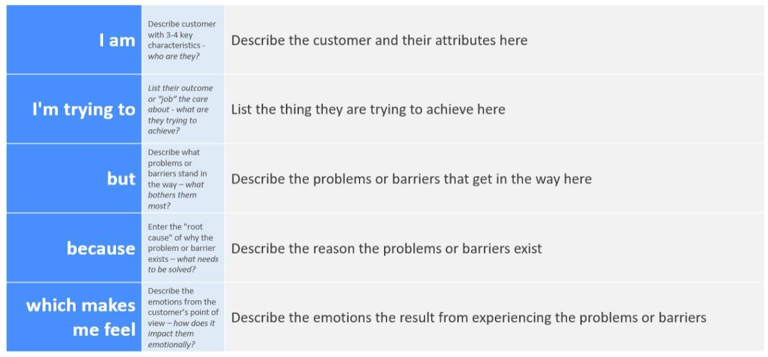
Reference: https://miro.com/templates/customer-problem-statement/ Example:
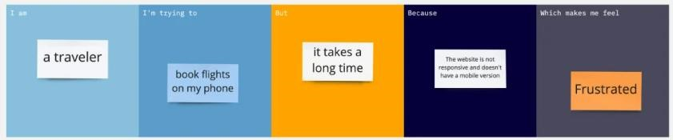
filters for
preferences
PS-2 | someone  booking for family | find affordable group flights | it’s hard to  compare  prices across airlines | there’s no side-by-side comparison feature | overwhelmed and stressed

